**PROJECT 1**

Dataset:

<https://github.com/swapnilsaurav/projects/blob/main/Healthcare_Enrollment_Trend_Dataset.xlsx>

Excercise:

|  |
| --- |
| To analyze trends and performance in healthcare enrollment activities, focusing on enrollment types, status distribution, agent performance, and plan type preferences over time. The goal is to identify bottlenecks, top-performing agents, and shifts in consumer preferences to improve operational efficiency and customer experience. **Key Data Visualization Questions:**  1. **Enrollment Trends Over Time**     * How has the number of enrollments (new, modification) changed month-over-month?    * Are there seasonal spikes in healthcare enrollments? 2. **Enrollment Type vs. Status**     * What is the distribution of enrollment statuses (Accepted, Pending, Rejected) across enrollment types?    * Which type of enrollments (New, Modification) face higher rejection or pending rates? 3. **Plan Type Popularity**     * Which plan types (Gold, Bronze, etc.) are most frequently selected?    * How do plan preferences vary by month or quarter? 4. **Agent Performance Analysis**     * Which agents have submitted the most enrollments?    * What is the acceptance rate for each agent?    * How does resolution time differ by agent? 5. **Resolution Time Analysis**     * What is the average resolution time by enrollment status?    * Are some plan types or enrollment types associated with longer resolution times? 6. **Submission Channel Trends**     * How do enrollment trends differ by the submitting agent/channel?    * Which channels are more efficient (faster resolution or higher acceptance)? 7. **Pending and Rejected Case Monitoring**     * Which agents or plan types have the most pending/rejected enrollments?    * Are there dates or periods with unusually high pending cases? |

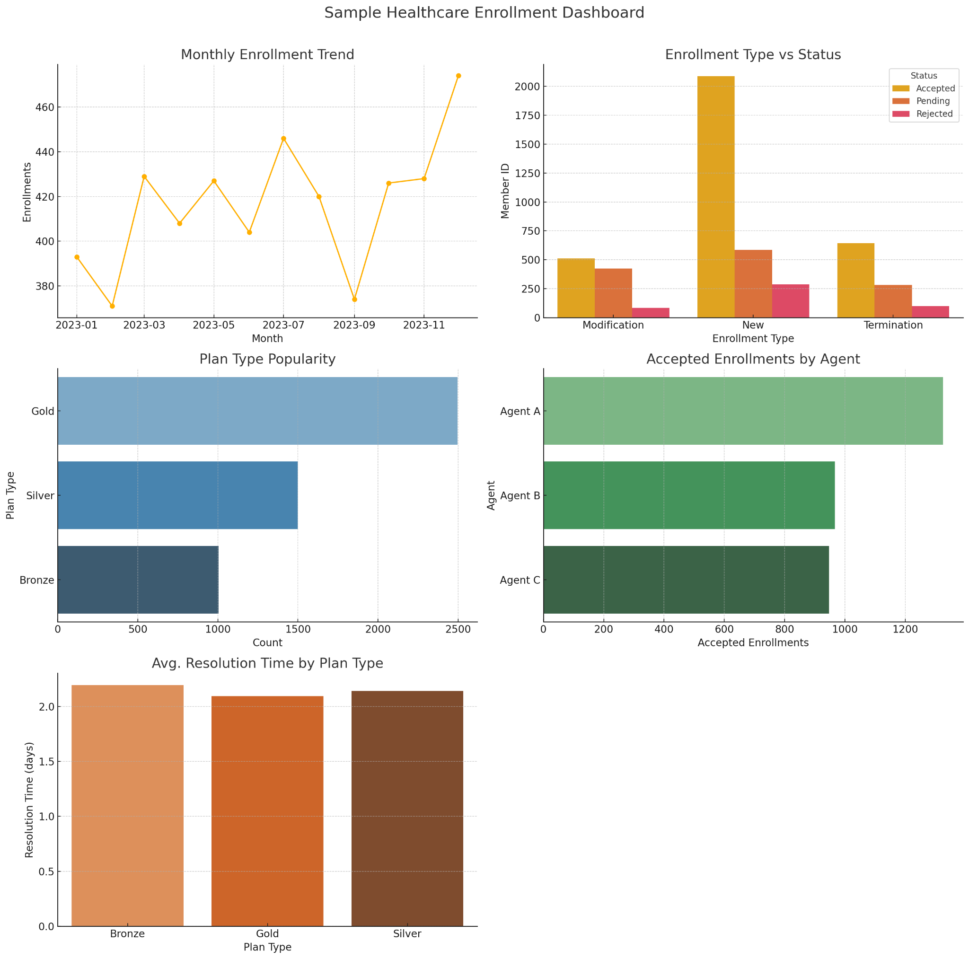

Solution:

|  |
| --- |
| **1. Enrollment Trends Over Time****Chart Type: Line Chart (Time Series)****Steps:**  1. Open Tableau and connect to your dataset. 2. Drag Date to **Columns** (right-click it, choose "Month" or "Week"). 3. Drag Member ID to **Rows** and change aggregation to **Count (Distinct)**. 4. Drag Enrollment Type to **Color** (optional for comparing types).  **2. Enrollment Type vs. Status****Chart Type: Stacked Bar Chart or Side-by-Side Bar Chart****Steps:**  1. Drag Enrollment Type to **Columns**. 2. Drag Member ID to **Rows** and set to **Count (Distinct)**. 3. Drag Status to **Color**. 4. For side-by-side comparison, drag Status to **Columns** after Enrollment Type.  **3. Plan Type Popularity****Chart Type: Horizontal Bar Chart****Steps:**  1. Drag Plan Type to **Rows**. 2. Drag Member ID to **Columns** (Count Distinct). 3. Sort descending. 4. Add Enrollment Type to **Color** or **Filter** for segmented views.  **4. Agent Performance Analysis****Chart Types:**  * Bar Chart (Enrollments per Agent) * Pie Chart or Donut Chart (Acceptance Rate) * Box Plot (Resolution Time Distribution)  **Steps for Enrollments per Agent:**  1. Drag Submitted By to **Rows**. 2. Drag Member ID to **Columns** (Count Distinct).  **Steps for Acceptance Rate:** Create a **Calculated Field**:  IF [Status] = "Accepted" THEN 1 ELSE 0 END   1. Drag Submitted By to Rows, and the new field to Columns (AVG aggregation). 2. Format as **Percentage**.  **Steps for Resolution Time:**  1. Drag Submitted By to **Columns**. 2. Drag Resolution Time (days) to **Rows**. 3. Use **Box-and-Whisker Plot** from “Show Me”.  **5. Resolution Time Analysis****Chart Types:**  * Heat Map (Status vs. Avg Resolution Time) * Line Chart (Avg Resolution Time Over Time)  **Steps for Heat Map:**  1. Drag Status to **Rows**. 2. Drag Enrollment Type to **Columns**. 3. Drag Resolution Time (days) to **Color** (Aggregation: AVG).  **Steps for Line Chart:**  1. Drag Date to Columns (Month). 2. Drag Resolution Time (days) to Rows (AVG). 3. Drag Status to Color.  **6. Submission Channel Trends****Chart Type: Bar Chart or Line Chart (Trend Over Time)****Steps:**  1. Drag Date to Columns (Month). 2. Drag Member ID to Rows (Count Distinct). 3. Drag Submitted By to **Color**.   **7. Pending and Rejected Case Monitoring**  **Chart Type: Highlight Table or Heatmap****Steps:**  1. Drag Submitted By to Rows. 2. Drag Status to Columns. 3. Drag Member ID to Text (Count Distinct). 4. Drag same measure to **Color** to highlight volume. |

**PROJECT 2**

**PROJECT 2: ANALYTICS IN TABLEAU**

### **1. Can we identify clusters of similar enrollments based on resolution time, plan type, and enrollment behavior?**

#### **Technique: Clustering**

* **Fields to use for clustering**:  
  1. Resolution Time (days) (numeric)
  2. Plan Type (convert to numeric or use dummy encoding)
  3. Enrollment Type (categorical)
  4. Submitted By (categorical, optional)
* **Steps**:  
  1. Drag relevant dimensions and measures into the view (e.g., Resolution Time vs Plan Type).
  2. Go to **Analytics pane > drag "Cluster" into view**.
  3. Tableau will automatically create clusters (can adjust number of clusters).
  4. Analyze characteristics of each cluster (e.g., Cluster 1 = quick resolutions for Gold plans).

### **2. What are the key factors that impact resolution time across submissions?**

#### **Technique: Trend Line & Correlation**

* **Chart**: Scatter Plot
* **Axes**:  
  1. X-axis: Submitted By or Enrollment Type
  2. Y-axis: Resolution Time (days)
* **Steps**:  
  1. Create scatter plot with Resolution Time vs other variables.
  2. Drag **Resolution Time** to Columns and Enrollment Type or Plan Type to Rows.
  3. Go to **Analytics pane > drag "Trend Line" into the view**.
  4. Choose **Linear** or **Polynomial**, observe R² value.

### **3. Can we predict future enrollment volume?**

#### **Technique: Forecasting**

* **Chart**: Line Chart (Time Series)
* **Field**: Date vs Enrollments (Count Distinct of Member ID)
* **Steps**:  
  1. Drag Date (Month) to Columns.
  2. Drag Member ID (Count Distinct) to Rows.
  3. Go to **Analytics pane > drag "Forecast" into view**.
  4. Adjust forecasting model (e.g., set forecast length to 3 months).

### **4. Which submission agents are outliers in performance or resolution time?**

#### **Technique: Box Plot with Outliers**

* **Chart**: Box Plot
* **X-axis**: Submitted By
* **Y-axis**: Resolution Time (days)
* **Steps**:  
  1. Drag Submitted By to Columns.
  2. Drag Resolution Time (days) to Rows.
  3. Go to **Show Me** and select **Box Plot**.
  4. Use outlier dots to identify underperforming or high-efficiency agents.

### **5. Are there patterns among rejected or pending enrollments?**

#### **Technique: Clustering with Filtering**

* **Steps**:  
  1. Filter the data to only include Status = Pending or Rejected.
  2. Apply **clustering** on features like Plan Type, Enrollment Type, Resolution Time, and Submitted By.
  3. Label clusters and analyze if certain agents or plans are overrepresented in problematic enrollments.

**Numeric Encoding of Plan Types** (e.g., Gold = 3, Silver = 2, Bronze = 1)

**Binary Encoding for Accepted Enrollments**:  
  
IF [Status] = "Accepted" THEN 1 ELSE 0 END